**6. ReactJS-HOL**

**Trainer.js**

export class Trainer {

constructor(id, name, phone, email, technology, skills) {

this.trainerId = id;

this.name = name;

this.phone = phone;

this.email = email;

this.technology = technology;

this.skills = skills;

}

}

**TrainersMock.js**

import { Trainer } from './Trainer';

const trainers = [

new Trainer(1, 'John Smith', '1234567890', 'john@example.com', 'Java', 'Spring, Hibernate'),

new Trainer(2, 'Alice Johnson', '2345678901', 'alice@example.com', '.NET', 'C#, ASP.NET'),

new Trainer(3, 'Bob Lee', '3456789012', 'bob@example.com', 'Python', 'Django, Flask'),

];

export default trainers;

**TrainersList.js**

import React from 'react';

import { Link } from 'react-router-dom';

function TrainersList({ trainers }) {

return (

<div>

<h2>Trainer List</h2>

<ul>

{trainers.map((trainer) => (

<li key={trainer.trainerId}>

<Link to={`/trainer/${trainer.trainerId}`}>{trainer.name}</Link>

</li>

))}

</ul>

</div>

);

}

export default TrainersList;

**Home.js**

import React from 'react';

function Home() {

return (

<div>

<h2>Welcome to Cognizant Academy Trainer Portal</h2>

<p>Manage all trainers and their expertise here.</p>

</div>

);

}

export default Home;

**TrainerDetails.js**

import React from 'react';

import { useParams } from 'react-router-dom';

import trainers from './TrainersMock';

function TrainerDetails() {

const { id } = useParams();

const trainer = trainers.find((t) => t.trainerId.toString() === id);

if (!trainer) return <h2>Trainer Not Found</h2>;

return (

<div>

<h2>Trainer Details</h2>

<p><strong>ID:</strong> {trainer.trainerId}</p>

<p><strong>Name:</strong> {trainer.name}</p>

<p><strong>Phone:</strong> {trainer.phone}</p>

<p><strong>Email:</strong> {trainer.email}</p>

<p><strong>Technology:</strong> {trainer.technology}</p>

<p><strong>Skills:</strong> {trainer.skills}</p>

</div>

);

}

export default TrainerDetails;

**App.js**

import React from 'react';

import { BrowserRouter as Router, Routes, Route, Link } from 'react-router-dom';

import Home from './Home';

import TrainersList from './TrainersList';

import TrainerDetails from './TrainerDetails';

import trainers from './TrainersMock';

function App() {

return (

<Router>

<div style={{ padding: '20px' }}>

<h1>Trainer Management</h1>

<nav>

<Link to="/" style={{ marginRight: '20px' }}>Home</Link>

<Link to="/trainers">Trainers</Link>

</nav>

<hr />

<Routes>

<Route path="/" element={<Home />} />

<Route path="/trainers" element={<TrainersList trainers={trainers} />} />

<Route path="/trainer/:id" element={<TrainerDetails />} />

</Routes>

</div>

</Router>

);

}

export default App;

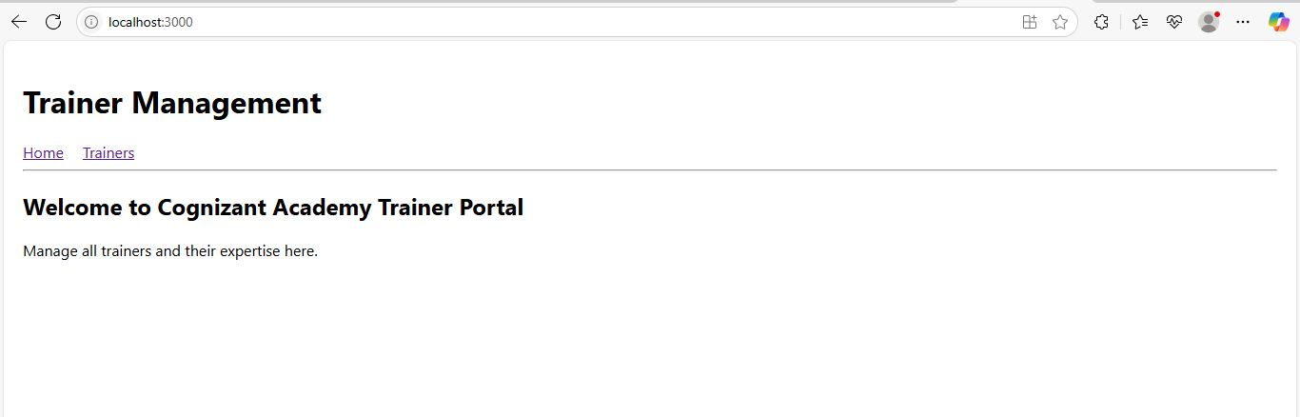

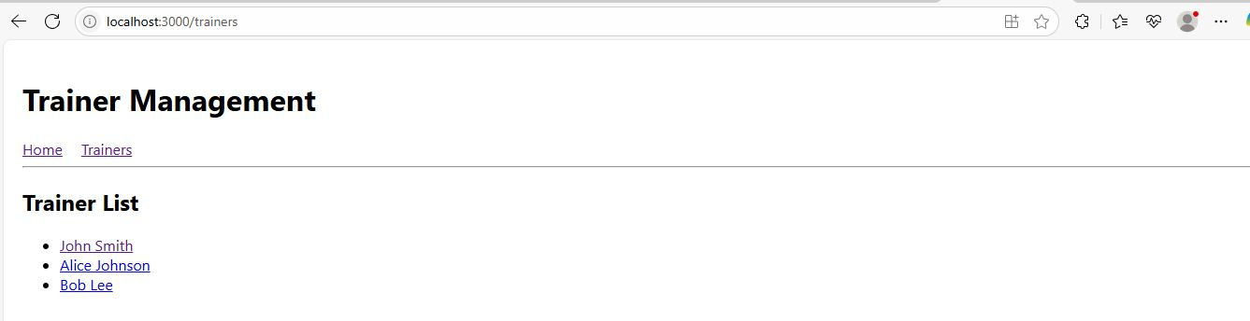

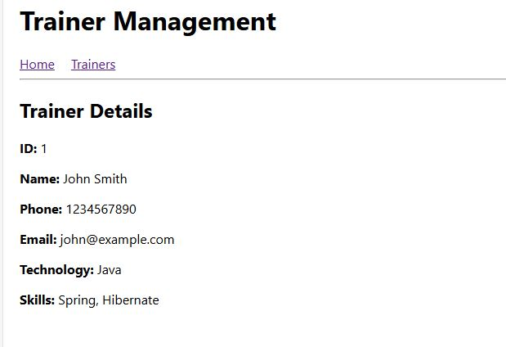

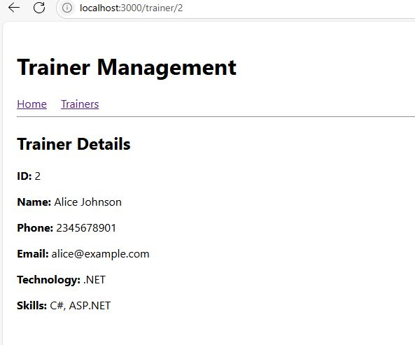

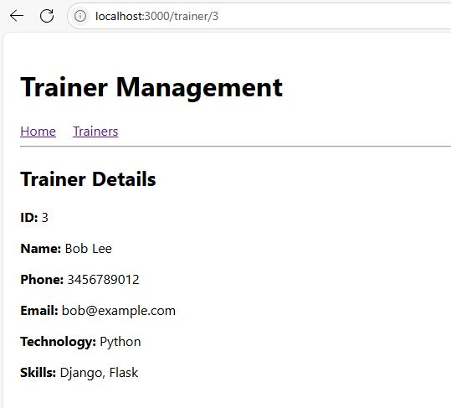

**1. Explain the need and benefits of React Router**

React Router allows navigation in a single-page application (SPA) without reloading the entire page. It improves performance and provides dynamic navigation.

**Benefits:**

* SPA experience without full reloads
* Dynamic route mapping
* Parameter-based routing
* URL reflects application state

**2. Identify the Components in React Router**

* <BrowserRouter>
* <Routes>
* <Route>
* <Link>
* useParams()
* useNavigate()

**3. List the types of Router Components**

* **BrowserRouter** – uses HTML5 history API
* **HashRouter** – uses hash in the URL (#)
* **MemoryRouter** – for testing or non-browser environments

**4. Parameter Passing via URL**

React Router allows parameters in route paths using : (e.g., /trainer/:id). The useParams() hook retrieves these values.